1. Lets see the question “ Delete only one value in the array?”
2. Please got through the below link before going to try the above question

<https://firebase.google.com/docs/firestore/manage-data/add-data#update_elements_in_an_array>

1. Lets see an example , first go through the below screenshot

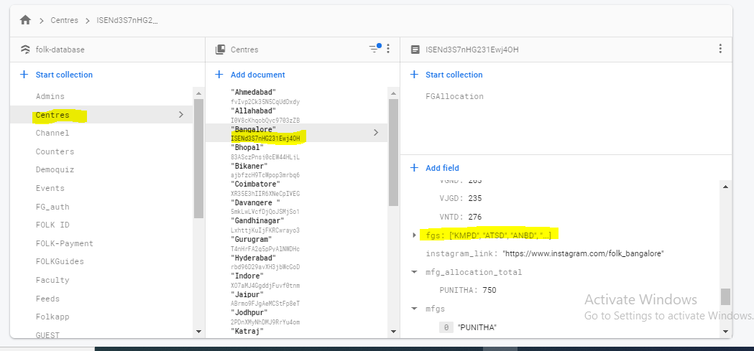

1. In Centres->docid->fgs(array attribute)
2. Now iam going remove one value in that attribute, please check below example
3. Docs = db.collection(u’Centres’).document(‘ISENd3S7nHG231Ewj4OH’)
4. Data = {

U’fgs’: firestore.ArrayRemove([‘ATSD’])

1. Docs.update(Data)
2. Now that value is deleted in that array, we can remove multiple array values at a time
3. This is the fixed and best process to remove the array values